Every winter friends and families travel via planes, trains and automobiles to different destinations in the USA to participate in one of the world’s favorite winters past times, skiing. In the US alone, an average of 4.44 billion dollars a year is spent on equipment with an additional 4.3 billion dollars spent on ski resorts. Skiers from all over the world and from all different walks of life go to ski resorts to enjoy each other’s company but more importantly skiing. The Big Mountain Ski Resort has placed itself in the top echelon of ski resorts in the United States by satisfying the needs of the skier.

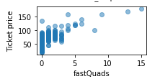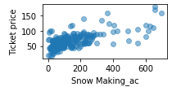Based on the data provided, when potential customers are picking out a resort, they look for the following things. Snow making capabilities, number of chairs, fast quads, night skiing were things that all the most expensive resorts in the country had in common. Essentially customers want to be skiing during their vacation. As the figures here indicate, resorts with more fast quads command a higher ticket price than those with none or a few fast Quads.

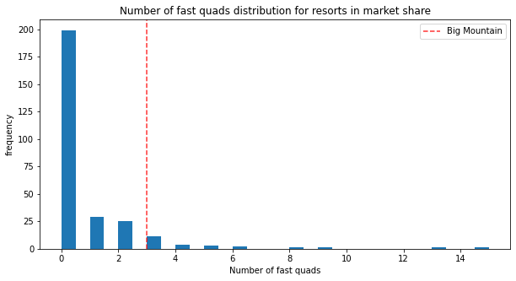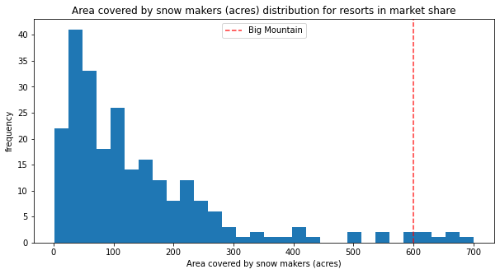The facilities of the Big Mountain Ski Resort compete with the most expensive resorts in the country. As the figures on the right show, Big Mountain Ski Resort has more acreage covered by snow makers, more fast quads and more ski lift chairs than the majority of the competition. As a matter of fact, it ranks near the top on everything that that a customer is willing to pay for. However, with a price of 81 dollars for a ski pass, our data models show that the resort is undercharging when compared with resorts with 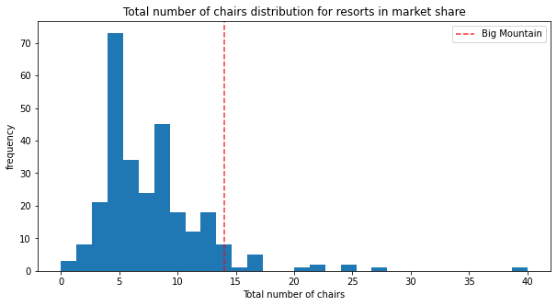similar facilities throughout the country. According to the data, the Big Mountain Ski Resort ski pass should be in the 89.81 – 99.88 range. A dynamic pricing system with a base price of 90.00 dollars as a base and going up 99.88 during peak times of the season would dramatically increase the profits of the resort. Furthermore, the data suggests that closing the least used 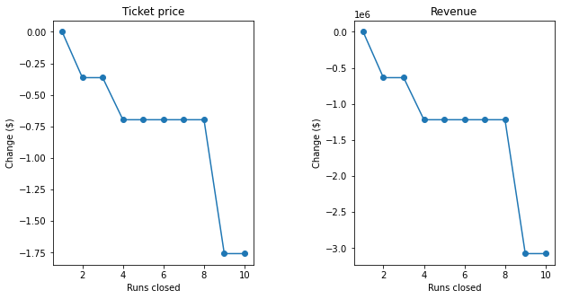run permanently will reduce costs without effecting the customer experience.